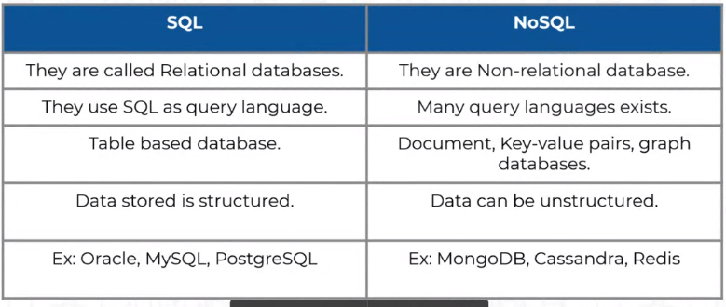





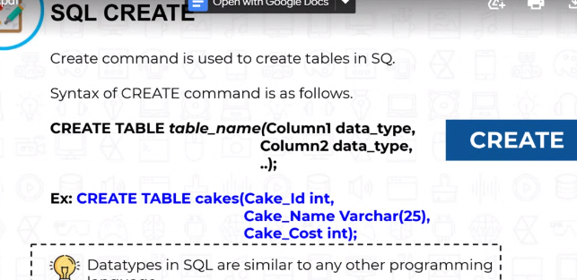

CREATE TABLE cakes(cake_id int,cake_name Varchar(25),Cake_Cost int);

INSERT into cakes(cake_id,cake_name,cake_cost)values(003,'RED VELVET',199);

INSERT into cakes(cake_id,cake_name,cake_cost)values(004,'CHOCOLATE',99);

INSERT into cakes(cake_id,cake_name,cake_cost)values(005,'VANILA',59)

CREATE table players(player_id int,name VARCHAR(25),date_of_birth VARCHAR(25),batting_hand VARCHAR(25),country VARCHAR(25));

INSERT into players(player_id,name,date_of_birth,batting_hand,country)values(1,'A Kumble','1970-10-11','right','india');

INSERT into players(player_id,name,date_of_birth,batting_hand,country)values(2,'Virat Kholi','1988-5-11','right','india');

INSERT into players(player_id,name,date_of_birth,batting_hand,country)values(3,'MS Dhoni','1998-7-7','right','india');

i

CREATE TABLE matches(

match_id int,

season varchar(10),

city varchar(25),

team1 varchar(40),

team2 varchar(40),

winner varchar(25)

);

INSERT INTO matches(match_id,season,city,team1,team2,winner)

VALUES

(1,'IPL-2019','Delhi','Mumbai Indians','Delhi Capitals','Mumbai Indians');

INSERT INTO matches(match_id,season,city,team1,team2,winner)

VALUES

(2,'IPL-201','Chennai','Mumbai Indians','Chennai Super Kings','Mumbai Indians');

INSERT INTO matches(match_id,season,city,team1,team2,winner)

VALUES

(3,'IPL-2019','Bangalore','Royal Challengers Bangalore','Delhi Capitals','Delhi Capitals');



‘